**Applied Databases**

**Topic 4 Exercise Sheet**

1. Get garage.sql from Moodle and import it into MySQL.

2. How are the tables in the database related?

Manu_code is the link between both tables



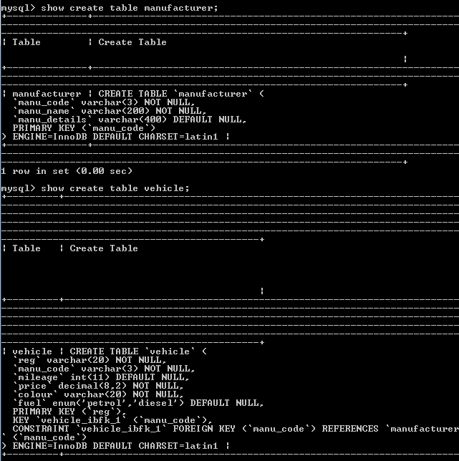

3. Show the manu_code, manu_name and the first 10 characters of the manu_details followed by three dots (…) for each manufacturer.

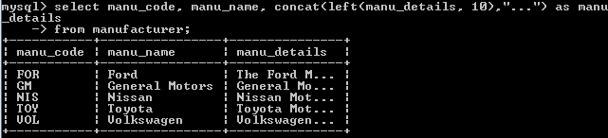



4. Show the average length of the manu_name (displayed as “Length”) with 0 characters after the decimal point. HINT: Functions needed are avg(), length() and format().

5. Show all details of all vehicles plus an extra column called “cost” which has the value 1.45 if the fuel is petrol otherwise has the value 1.30.

6. Show all the reg, manu_code and associated manu_name for each vehicle.

7. Show the manu_code and manu_name as well as associated reg, for each manufacturer who has vehicles listed in the vehicle table.

8. Show the manu_code and manu_name as well as associated reg, for all manufacturers and if they have vehicles listed in the vehicle table, show the reg of it.

9. Write a stored procedure called price_less_than that takes one parameter of type decimal(8,2) which represents the price of a vehicle: price_less_than(p decimal(8,2)) The procedure should then return the following details for all vehicles where the price of the vehicle is less than p sorted by ascending price:

• Reg

• Manu_code

• Manu_name

• Mileage

• Price